**Sunzid Hassan**

**ID: 10407862**

**Model 1**

**Project 1**

1. 2D concentration map profiles with added flux streamlines for the times of 10 ms, 30 ms, and 70 ms. (porous matrix)

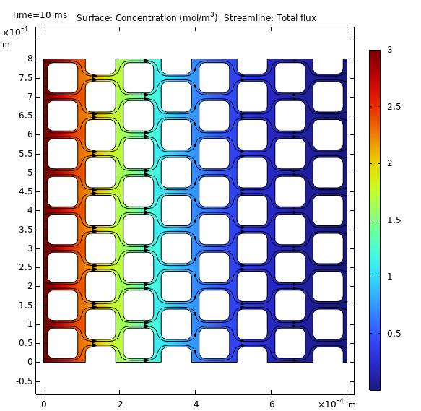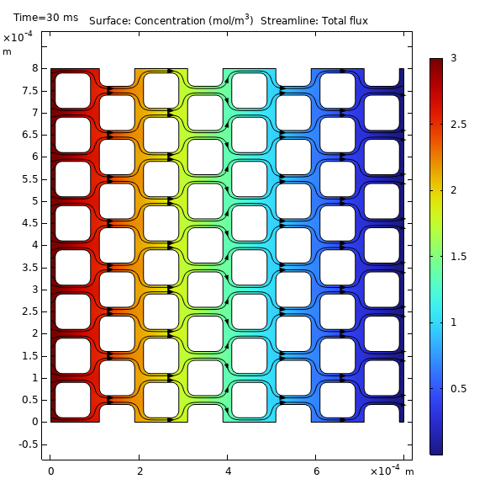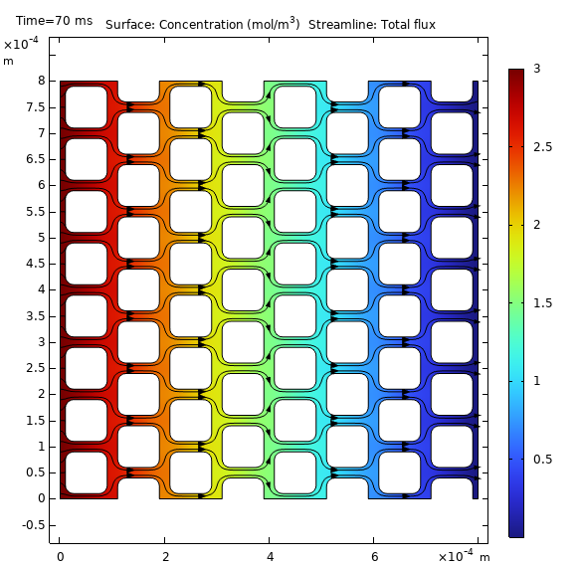

Figure 1: 2D concentration map profile with added flux streamlines for the times of 10 ms, 30 ms and 70s.

1. **10 ms**: The solute just begins to diffuse, establishing initial concentration gradients. The flux streamlines illustrate early transport patterns.
2. **30 ms**: The solute continues to spread, revealing clearer diffusion pathways within the porous matrix. The streamlines emphasize these emerging routes.
3. **70 ms**: Diffusion progresses, forming additional concentration gradients. The flux streamlines now depict flow patterns nearing equilibrium.
4. 1D plot of molar flux vs. time. (porous matrix)

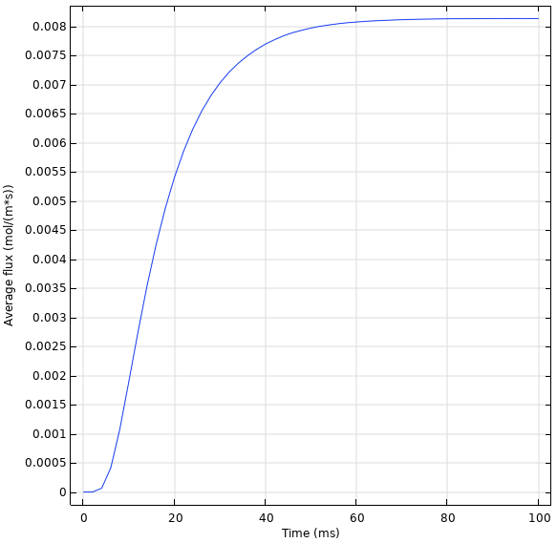

Figure 2: 1D plot of molar flux vs. time.

The molar flux initially rises as the concentration gradient drives diffusion. As time progresses and the system nears steady-state, the flux stabilizes.

1. 1D plot of concentration profile (concentration vs. length) at 10 ms intervals between 0 and 100 ms. (unidirectional diffusion)

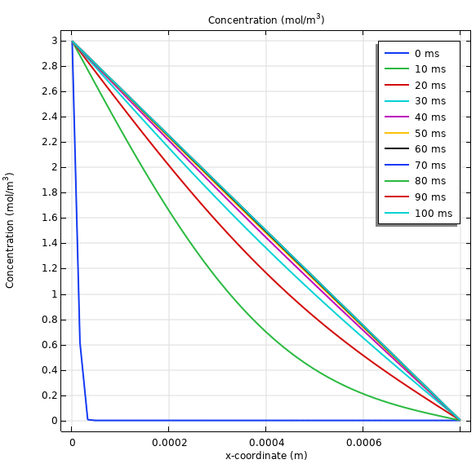

Figure 3: Concentration profile.

These profiles illustrate how concentration evolves over time. Early in the process, a steep gradient promotes rapid diffusion, while later measurements show the concentration gradually leveling off toward a more uniform distribution.

1. Geometry map of your maze (no solute concentration; use geometry tab to show shape)

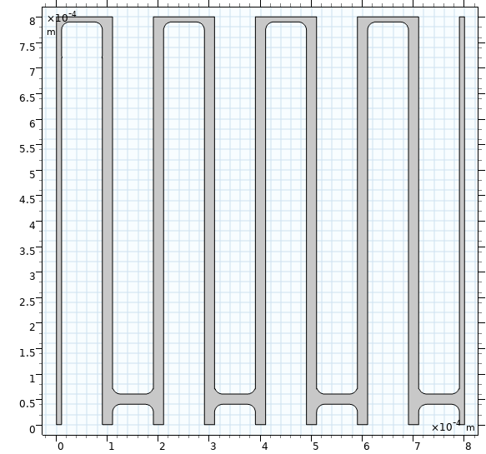

Figure 4: Geometry map of maze.

1. 2D concentration map showing progressing of concentrated solute through your maze at 3 times (beginning, middle, and end)

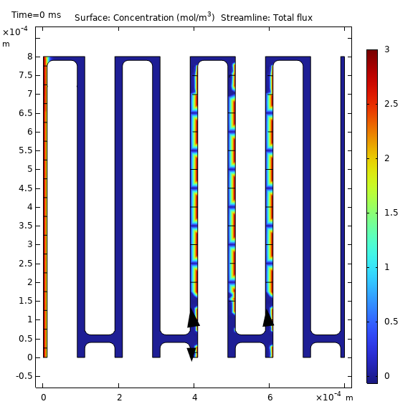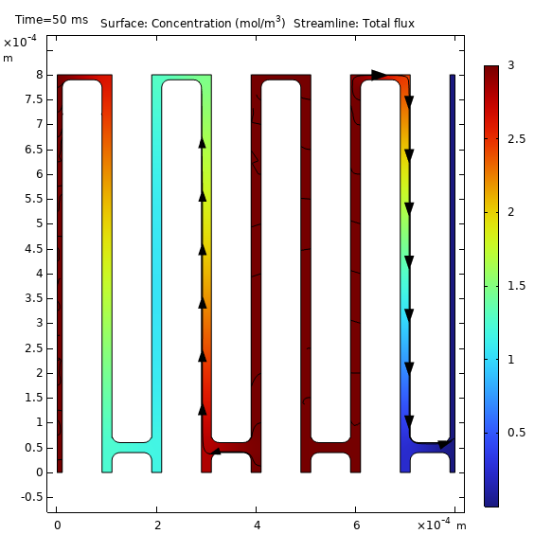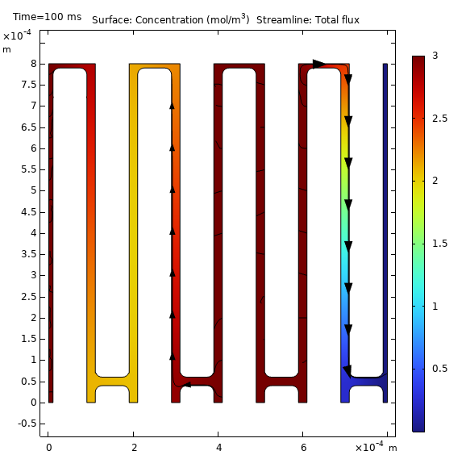

Figure 5: 2D concentration map showing progressing of concentrated solute through the maze at times 0s, 50s and 100s.

Displays the concentration of solute (in mol/m³) as it traverses the maze at three stages: (a) the beginning, (b) the middle, and (c) the end.

* **Beginning:** The solute starts off at a high concentration in its initial region, with minimal dispersal into the surrounding pathways.
* **Middle:** As diffusion proceeds, the solute moves further into the maze, following concentration gradients and gradually spreading throughout the available channels.
* **End:** Eventually, the solute reaches a near-uniform distribution, with diminishing concentration differences along the maze’s pathways.

1. Concluding paragraph discussing how we can model a complex geometry as a uniform block using an effective diffusion. Also discuss how Fick’s Laws demonstrate a solute’s ability to navigate a fluidic maze.

When dealing with intricate geometries—such as porous media or microfluidic channels—it becomes necessary to simplify the system for modeling. One effective method is to treat the complex structure as if it were a uniform block, but with a modified, "effective" diffusion coefficient. This adjusted coefficient captures the additional resistance to solute movement caused by the twists, turns, and narrow passages present in the real geometry. By determining this effective diffusion either experimentally or computationally, we can employ simpler uniform-block models that reduce computational demands without sacrificing much accuracy. Moreover, Fick's Laws offer the foundational principles for understanding solute transport in such environments. Fick's first law links the diffusive flux to the concentration gradient, explaining why solutes naturally flow from areas of high to low concentration—even in complex structures, though the rate is diminished by obstacles. Meanwhile, Fick's second law, which describes the time-dependent change in concentration, enables us to predict how solute distribution evolves toward equilibrium. In summary, using the concept of effective diffusion together with Fick's laws allows us to simplify and accurately model solute transport in even the most complicated fluidic systems.